**Anjuman-I-Islam’s**

M.H. Saboo Siddik Polytechnic

8 , M.H. Saboo Siddik Polytechnic Road, Mumbai, 400008



SECOND YEAR DIPLOMA IN COMPUTER ENGINEERING

(2022-23)

PROJECT REPORT ON

**ONLINE FOOD DELIVERY APP**

By

210450 – Adnan Shaikh

210451 - Abdurrahman Qureshi

210453 - Ansari Saad

210460 - Arya More

210463 - Adnan Kazi

UNDER THE GUIDANCE OF

**Mr. Mohd Zaid & Mrs. Shafaque Julaha**



Maharashtra State Board of Technical Education (MS-BTE)



**MAHARASHTRA STATE**

**BOARD OF TECHNICAL EDUCATION**

**Certificate**

This is to certify that Mr. Adnan Shaikh Roll no. 210450 of fourth semester of Diploma in Computer Engineering of institute M.H. Saboo Siddik Polytechnic(code: 0002) has completed microproject satisfactorily in the subject: GAD (22034) for the academic year 2022-23 as prescribed in the curriculum.

Place: Byculla, Mumbai Enrolment no:2100020129

Date: ______________ Exam seat no:

Signature Signature Signature

Project guide H. O. D Principal

SEAL OF

INSTITUTE



**MAHARASHTRA STATE**

**BOARD OF TECHNICAL EDUCATION**

**Certificate**

This is to certify that Mr. Abdurrahman Qureshi Roll no. 210451 of fourth semester of Diploma in Computer Engineering of institute M.H. Saboo Siddik Polytechnic(code: 0002) has completed microproject satisfactorily in the subject: GAD(22034) for the academic year 2022-23 as prescribed in the curriculum.

Place: Byculla, Mumbai Enrolment no:2100020112

Date: ______________ Exam seat no:

Signature Signature Signature

Project guide H. O. D Principal

SEAL OF

INSTITUTE



**MAHARASHTRA STATE**

**BOARD OF TECHNICAL EDUCATION**

**Certificate**

This is to certify that Mr. Ansari Saad Roll no. 210453 of fourth semester of Diploma in Computer Engineering of institute M.H. Saboo Siddik Polytechnic(code: 0002) has completed microproject satisfactorily in the subject: GAD (22034) for the academic year 2022-23 as prescribed in the curriculum.

Place: Byculla, Mumbai Enrolment no:2100020102

Date: ______________ Exam seat no:

Signature Signature Signature

Project guide H. O. D Principal

SEAL OF

INSTITUTE



**MAHARASHTRA STATE**

**BOARD OF TECHNICAL EDUCATION**

**Certificate**

This is to certify that Mr. Arya More Roll no. 210460 of fourth semester of Diploma in Computer Engineering of institute M.H. Saboo Siddik Polytechnic(code: 0002) has completed microproject satisfactorily in the subject: GAD (22034) for the academic year 2022-23 as prescribed in the curriculum.

Place: Byculla, Mumbai Enrolment no:2100020097

Date: ______________ Exam seat no:

Signature Signature Signature

Project guide H. O. D Principal

SEAL OF

INSTITUTE



**MAHARASHTRA STATE**

**BOARD OF TECHNICAL EDUCATION**

**Certificate**

This is to certify that Mr. Adnan Kazi Roll no. 210463 of fourth semester of Diploma in Computer Engineering of institute M.H. Saboo Siddik Polytechnic(code: 0002) has completed microproject satisfactorily in the subject: GAD(22034) for the academic year 2022-23 as prescribed in the curriculum.

Place: Byculla, Mumbai Enrolment no:2100020117

Date: ______________ Exam seat no:

Signature Signature Signature

Project guide H. O. D Principal

SEAL OF

INSTITUTE

**Acknowledgment**

We wish to express our profound gratitude to our guide **Mr. Mohd Zaid Sir & Mrs. Shafaque Julaha Ma’am** who guided us endlessly in the framing and completion of the micro project. She guided us on all the main points in that micro project. We are indebted to their constant encouragement, cooperation, and help. It was their enthusiastic support that helped us in overcoming various obstacles in the micro-project. We are also thankful to our Principal, HOD, faculty members and classmates of Computer Engineering department for extending their support and motivation in the completion of this micro-project.

Names of Team Members with Roll Nos.

1. Adnan Shaikh - 210450
2. Abdurrahman Qureshi - 210451
3. Ansari Saad - 210453
4. Arya More - 210460
5. Adnan Kazi - 210463

*Annexure-I*

*Microproject proposal*

***Title of microproject:*** ***ONLINE FOOD DELIVERY APP***

**I**. **Aims/Benefits of microproject**

Food-delivery apps allow customers to order from a nearby restaurant at their convenience. The customers can get their order delivered, they can pick it up themselves or they can dine in. The restaurants receive the order on the restaurant app and prepare the meal. It also gives the customers the advantage of reordering the favorite order in the easiest and hassle-free manner.

**II. Course outcomes addressed**

* Ordering process is easy
* Ordering online is convenient
* No more waiting in long queues to place an order
* Increased transparency in pricing

**III. Proposed methodology**

1. To search the information about the project. (Collect relevant data from different sources i.e. books/internet and others through surveys/interviews etc.).

2. To collect all relevant content / materials to complete the project.

3. To prepare the report of micro project.

4. To prepare presentation.

5. To deliver presentation/ appear for viva-voice

- Discussion of the given topic among group members.

- Literature survey

- Submission of project proposal

- Analysis of data

- Work divided among group members

- Compilation of content

- Representation

- Editing the content as per the instructions

- Report Preparation

- Viva and presentation

*Annexure-I*

#### IV. Action Plan

|  |  |  |  |  |
| --- | --- | --- | --- | --- |
| **Weeks** | **Details of activity** | **Planned start date** | **Planned finish date** | **Name of responsible team members** |
| 1& 2 | Discussions & finalization of topics |  |  |  |
| 3 | Preparation of abstract |  |  |  |
| 4 | Literature review |  |  |  |
| 5 | Submission of Micro-Project proposal(Annexure -I) |  |  |  |
| 6 | Collection of information on given topic |  |  |  |
| 7 | Collection of all relevant contents |  |  |  |
| 8 | Discussion and submission of outline of the project |  |  |  |
| 9 | Analysis/execution of collected data/information and Preparation of prototypes/drawings/charts/graphs/ tables/models/circuits/programs etc. |  |  |  |
| 10 | Compilation of contents of project |  |  |  |
| 11 | Compilation of weekly progress report |  |  |  |
| 12 | Preparation of the project report (Annexure II) |  |  |  |
| 13 | Viva Voce / Delivery of presentation. |  |  |  |

#### V. Resources required

|  |  |  |  |  |
| --- | --- | --- | --- | --- |
| **Sr. no.** | **Name of resources** | **Specifications** | **Qty** | **Remarks** |
| 1. | Online | Learning resources and various websites | 5 sites |  |
| 2. | Desktop | Microsoft word, Tools with internet facility. | 1 for each |  |

Names of Team Members with Roll Nos.

1. 210450 Adnan Shaikh

2. 210451 Abdurrahman Qureshi

3. 210453 Saad Ansari

4. 210460 Arya More

5. 210463 Adnan Kazi

Approved by:

Sign of Faculty:

Name of faculty: Mr. Mohammed Zaid

*Annexure-II*

***Micro-Project Report***

**Title of Micro-project:** **ONLINE FOOD DELIVERY APP**

1. **Rationale**

The best online food ordering system helps enhance customer-restaurant relationships by offering a user-friendly admin panel. You can manage new, active, and cancelled orders from a single dashboard. In addition, the food ordering system will notify you as soon as you receive a new order so you can start the preparation instantly, fulfilling it quickly. You can also receive Online Reservations for Tables and Party orders. This will help you plan things efficiently and run operations smoothly.

**II. Aims/Benefits of microproject**

Food-delivery apps allow customers to order from a nearby restaurant at their convenience. The customers can get their order delivered, they can pick it up themselves or they can dine in. The restaurants receive the order on the restaurant app and prepare the meal.

**III. Course outcomes achieved**

1. Ordering process is easy
2. Ordering online is convenient
3. No more waiting in long queues to place an order
4. Increased transparency in pricing
5. **Literature Review**

Visual Basic .NET (VB.NET) is an object-oriented computer programming language implemented on the .NET Framework. Although it is an evolution of classic Visual Basic language, it is not backwards-compatible with VB6, and any code written in the old version does not compile under VB.NET.

The latest version of Microsoft Visual Basic (2012) is built upon the Microsoft.NET Framework. It has finally become a fully-fledged Object Oriented Language with all the associated features one would come to expect. It allows Visual Basic programmers to tackle much larger applications, through improved scalability and reusability. Decision making structures require that the programmer specify one or more conditions to be evaluated or tested by the program, along with a statement or statements to be executed if the condition is determined to be true, and optionally, other statements to be executed if the condition is determined to be false. There may be a situation when you need to execute a block of code several number of times. In general, statements are executed sequentially:

The first statement in a function is executed first, followed by the second, and so on. A procedure is a group of statements that together perform a task when called. After the procedure is executed, the control returns to the statement calling the procedure. VB.Net has two types of procedures: • Functions • Sub procedures or Subs Functions return a value, whereas Subs do not return a value. Under Visual Studio.NET, a VB class module is inserted into a project using the Add Class menu item on the Project menu. This inserts a new module containing the code: Public Class ClassName End Class Although Visual Studio stores each class in a separate file, this isn’t a requirement. It is the Class...End Class construct that marks the beginning and end of a class definition.

Thus, the code for more than one class as well as one or more code modules (which are similarly delimited by the Module...End Module construct) can be contained in a single source code file. An exception is a problem that arises during the execution of a program. An exception is a response to an exceptional circumstance that arises while a program is running, such as an attempt to divide by zero. Exceptions provide a way to transfer control from one part of a program to another. VB.Net exception handling is built upon four keywords: Try, Catch and Finally.

**VB.Net - Form Control:-**

|  |  |
| --- | --- |
| **PROPERTY** | **DESCRIPTION** |
| Name | This is the actual name of the form. |
| Text | The text, which will appear at the title bar of the form. |

**Form Events:-**

|  |  |
| --- | --- |
| **EVENT** | **DESCRIPTION** |
| Load | Occurs before a form is displayed for the first time. |
| Event | Description |

**ListBox Properties:-**

|  |  |
| --- | --- |
| **PROPERTY** | **DESCRIPTION** |
| Items | Gets the items of the list box. |
| MultiColumn | Gets or sets a value indicating whether the list box supports multiple columns. |
| SelectedIndex | Gets or sets the zero-based index of the currently selected item in a list box. |
| SelectedItem | Gets or sets the currently selected item in the list box |
| Sorted | Gets or sets a value indicating whether the items in the list box are sorted alphabetically. |
| Text | Gets or searches for the text of the currently selected item in the list box. |

**NumericUpDown :-**

NumericUpDown is basically countered that the user can input a number within the specified range. With the Help of NumericUpDown Control, we can enter numeric values, with advanced features like up-down buttons and accelerating auto-repeat.

**How to use NumericUpDown Control**

Drag and drop NumericUpDown Control from the toolbox on window Form.

The numeric value of the Windows Forms [NumericUpDown](https://learn.microsoft.com/en-us/dotnet/api/system.windows.forms.numericupdown) control is determined by its [Value](https://learn.microsoft.com/en-us/dotnet/api/system.windows.forms.numericupdown.value) property. You can write conditional tests for the control's value just as with any other property. Once the [Value](https://learn.microsoft.com/en-us/dotnet/api/system.windows.forms.numericupdown.value) property is set, you can adjust it directly by writing code to perform operations on it, or you can call the [UpButton](https://learn.microsoft.com/en-us/dotnet/api/system.windows.forms.numericupdown.upbutton) and [DownButton](https://learn.microsoft.com/en-us/dotnet/api/system.windows.forms.numericupdown.downbutton) methods.

CheckBox:-

The CheckBox control allows the user to set true/false or yes/no type options. The user can select or deselect it. When a check box is selected it has the value True, and when it is cleared, it holds the value False.

## **Properties of the CheckBox Control**

The following are some of the commonly used properties of the CheckBox control −

|  |  |
| --- | --- |
| 1 | **Appearance**  Gets or sets a value determining the appearance of the check box. |
| 2 | **AutoCheck**  Gets or sets a value indicating whether the Checked or CheckedState value and the appearance of the control automatically change when the check box is selected. | |
| 3 | **CheckAlign**  Gets or sets the horizontal and vertical alignment of the check mark on the check box. | |
| 4 | **Checked**  Gets or sets a value indicating whether the check box is selected. | |
| 5 | **CheckState**  Gets or sets the state of a check box. | |
| 6 | **Text**  Gets or sets the caption of a check box. | |

**PictureBox in vb net:-**

The PictureBox control is used for displaying images on the form. The Image property of the control allows you to set an image both at design time or at run time. Let's create a picture box by dragging a PictureBox control from the Toolbox and dropping it on the form.

## **Properties of the PictureBox Control**

The following are some of the commonly used properties of the PictureBox control −

|  |  |
| --- | --- |
| 1 | **AllowDrop**  Specifies whether the picture box accepts data that a user drags on it. |
| 2 | **ErrorImage**  Gets or specifies an image to be displayed when an error occurs during the image-loading process or if the image load is cancelled. |
| 3 | **Image**  Gets or sets the image that is displayed in the control. |
| 4 | **ImageLocation**  Gets or sets the path or the URL for the image displayed in the control. |
| 5 | **InitialImage**  Gets or sets the image displayed in the control when the main image is loaded. |
| 6 | **SizeMode**  Determines the size of the image to be displayed in the control. This property takes its value from the PictureBoxSizeMode enumeration, which has values −   * **Normal** − the upper left corner of the image is placed at upper left part of the picture box * **StrechImage** − allows stretching of the image * **AutoSize** − allows resizing the picture box to the size of the image * **CenterImage** − allows centering the image in the picture box * **Zoom** − allows increasing or decreasing the image size to maintain the size ratio. |
| 7 | **TabIndex**  Gets or sets the tab index value. |
| 8 | **TabStop**  Specifies whether the user will be able to focus on the picture box by using the TAB key. |
| 9 | **Text**  Gets or sets the text for the picture box. |
| 10 | **WaitOnLoad**  Specifies whether or not an image is loaded synchronously. |

**Panel:-**

The Panel control works as a container for other controls on the page. It controls the appearance and visibility of the controls it contains. It also allows generating controls programmatically. The Panel control is similar to the GroupBox control; however, only the Panel control can have scroll bars, and only the GroupBox control displays a caption.

|  |  |
| --- | --- |
| **Properties** | **Description** |
| BackImageUrl | URL of the background image of the panel. |
| DefaultButton | Gets or sets the identifier for the default button that is contained in the Panel control. |
| Direction | Text direction in the panel. |
| GroupingText | Allows grouping of text as a field. |
| HorizontalAlign | Horizontal alignment of the content in the panel. |
| ScrollBars | Specifies visibility and location of scrollbars within the panel. |
| Wrap | Allows text wrapping. |

**V. Actual Methodology Followed**

We were assigned with the microproject topic and time was assigned to us to complete the project in 11 weeks. All team members worked together in these 11 weeks together in order to complete this microproject. Data was collected according to our topic. Presentation was prepared, technical report was prepared and then we prepared ourselves to deliver the presentation.

1. **Actual resources used**

|  |  |  |  |  |
| --- | --- | --- | --- | --- |
| **Sr. no.** | **Name of resources** | **Specifications** | **Qty** | **Remarks** |
| 1. | Computer | i3 – i5 | 1 for each |  |
| 2. | Visual Studio | 2012 | 1 for each |  |
| 3. | Ms - Word | 2019 | 1 for each |  |
| 4. | Websites for quality images | Pexels , Flaticon | 1 for each |  |

**VII. Outputs of Microproject**

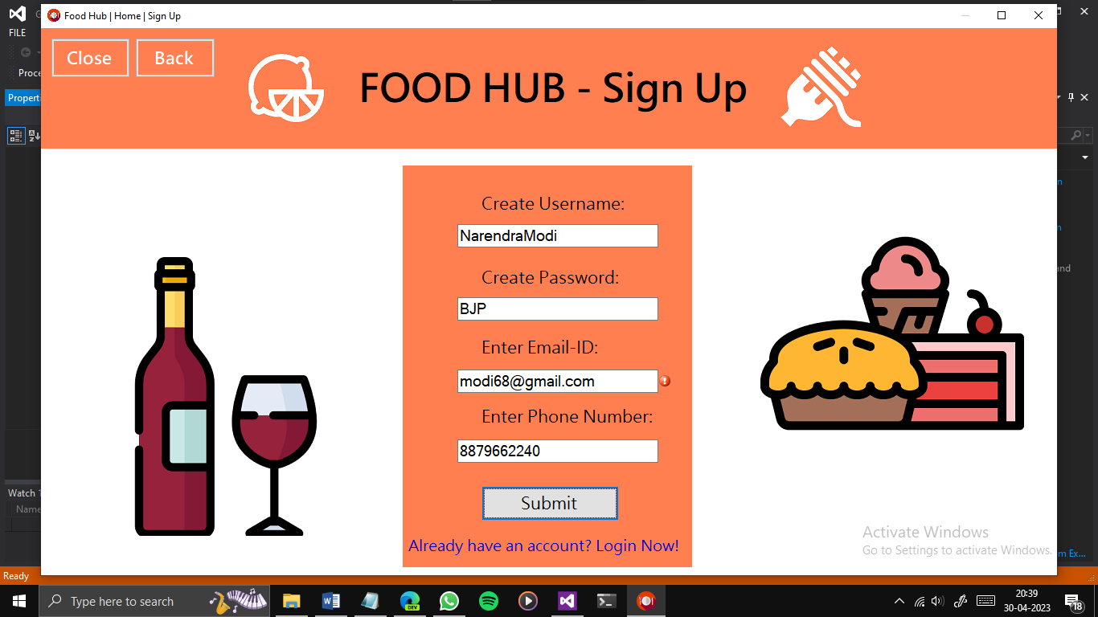

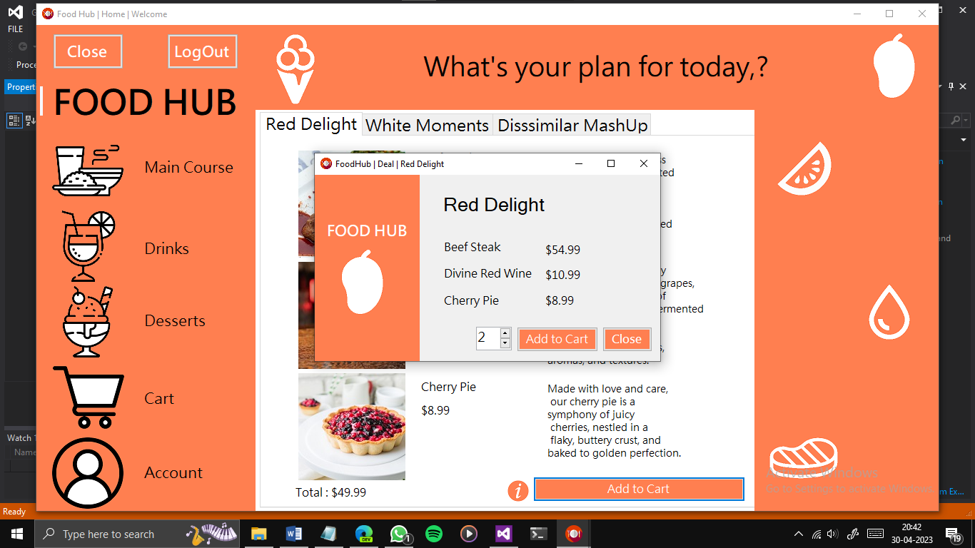 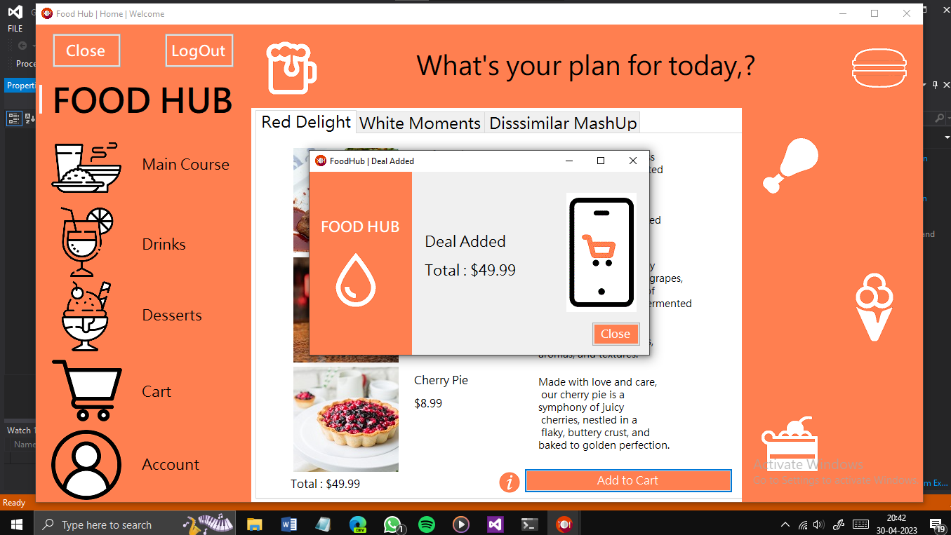 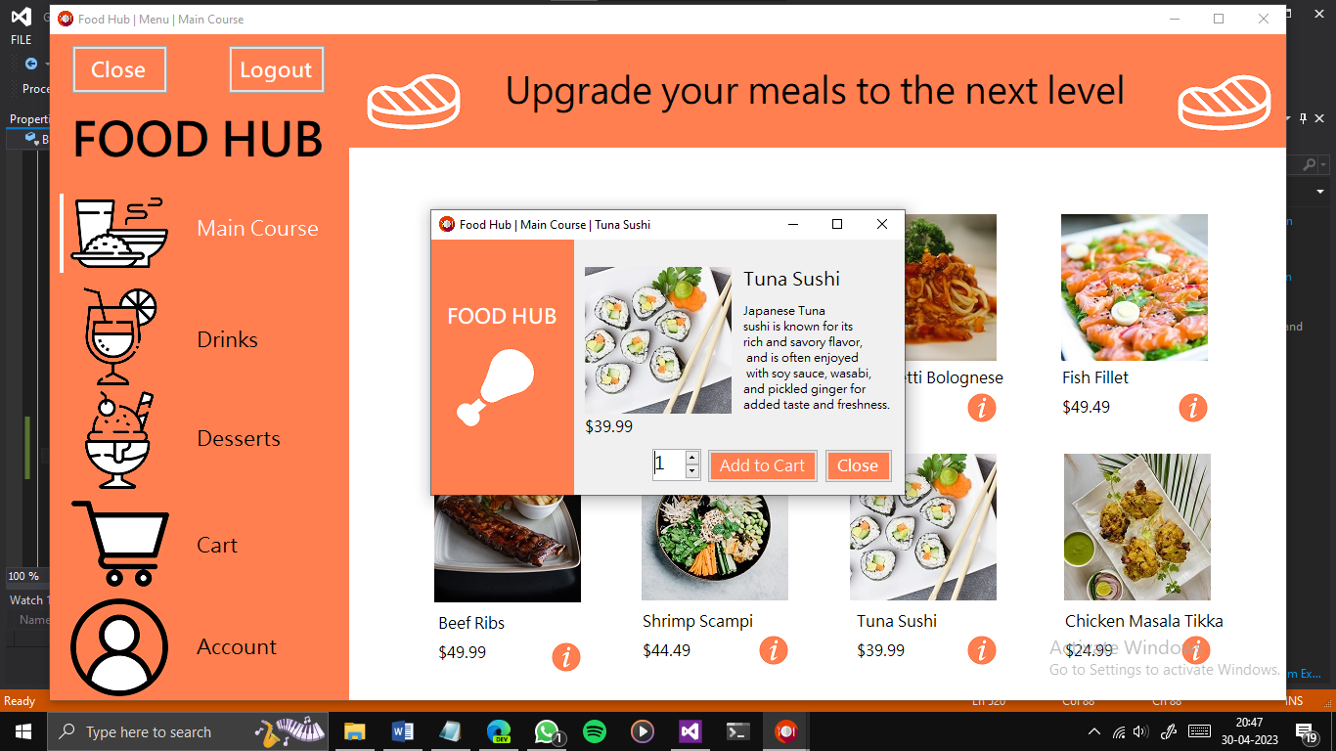 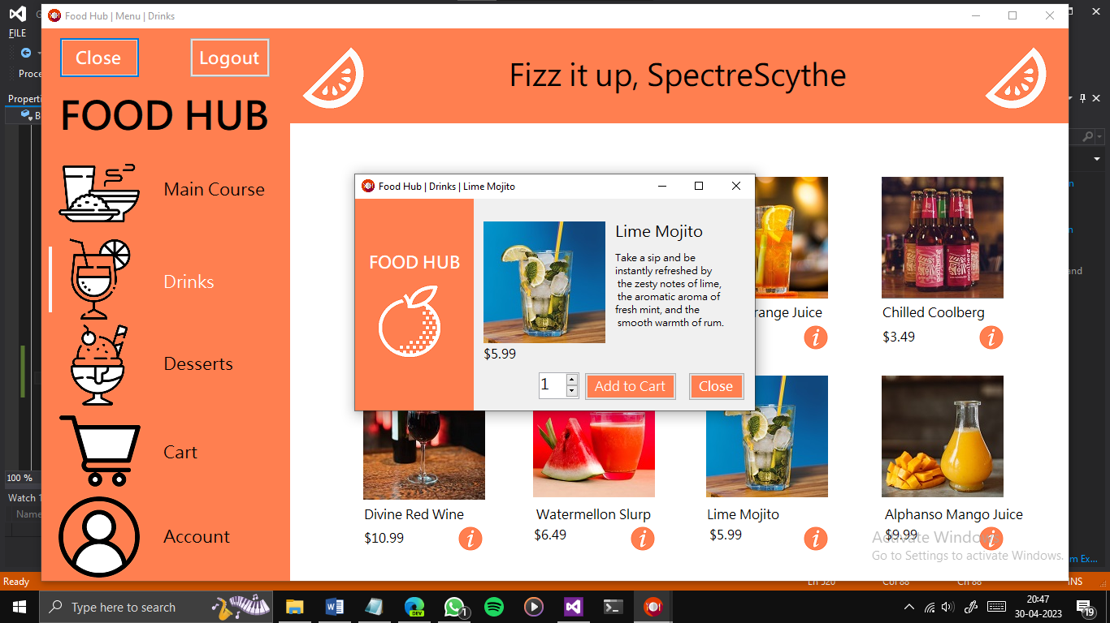 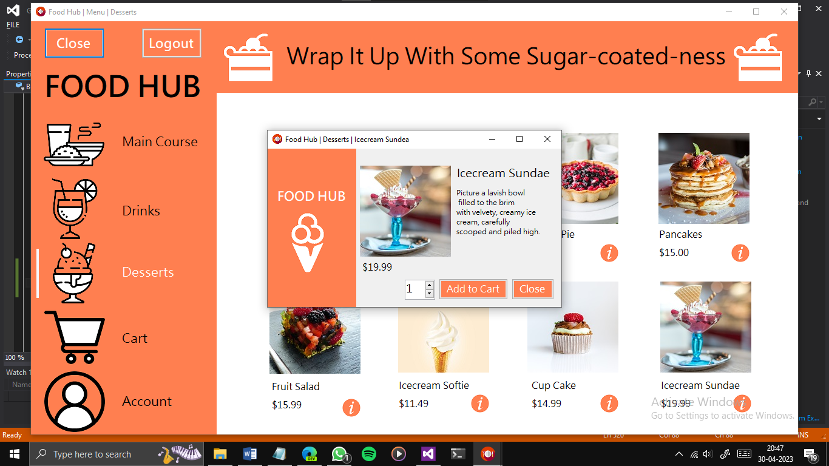

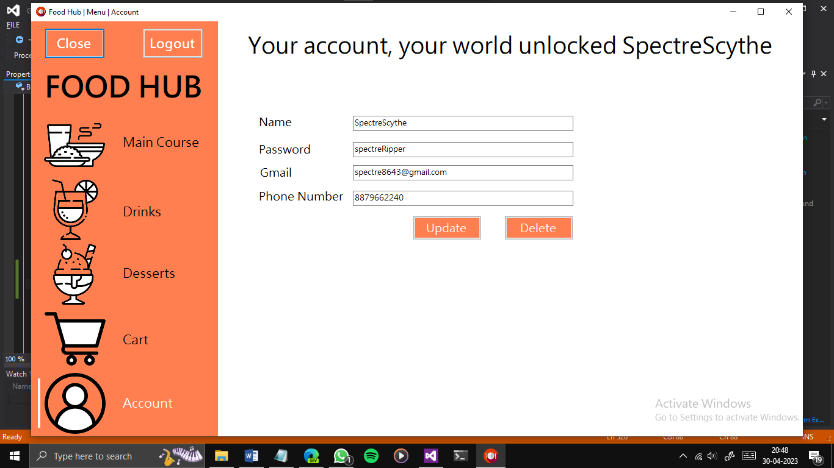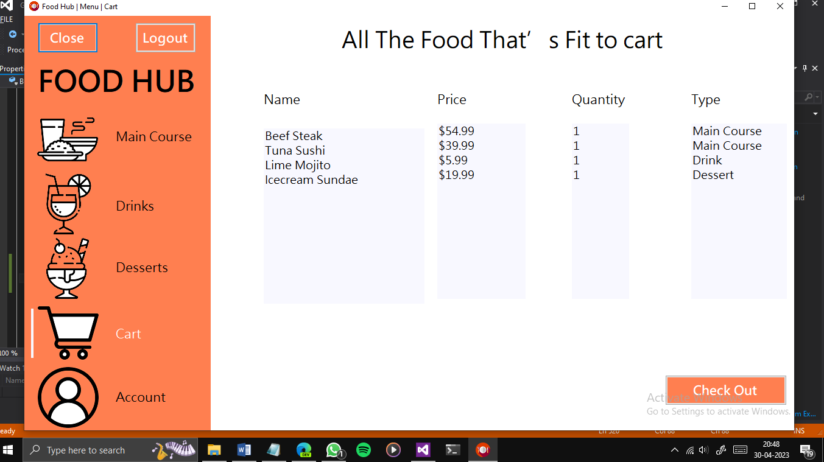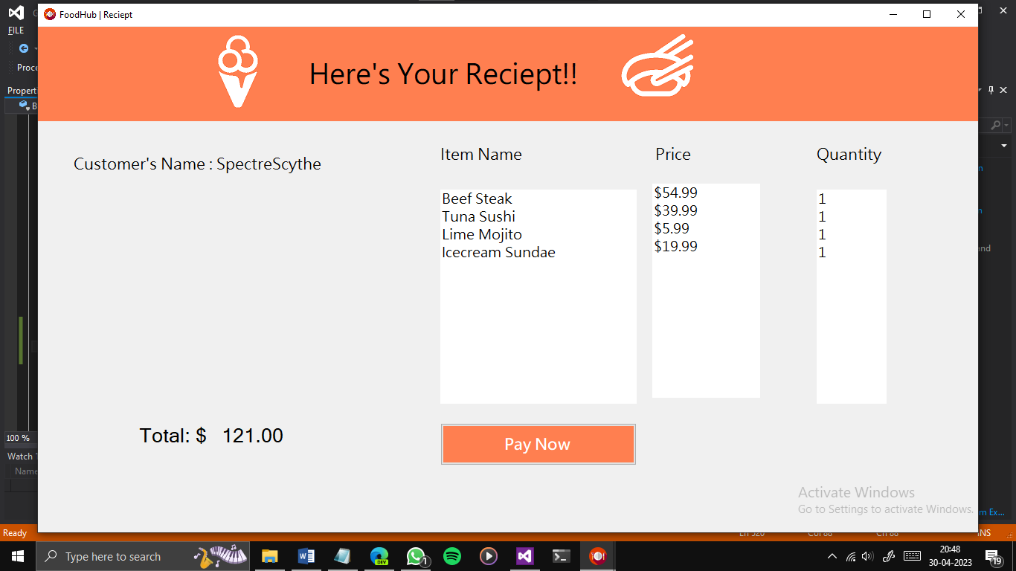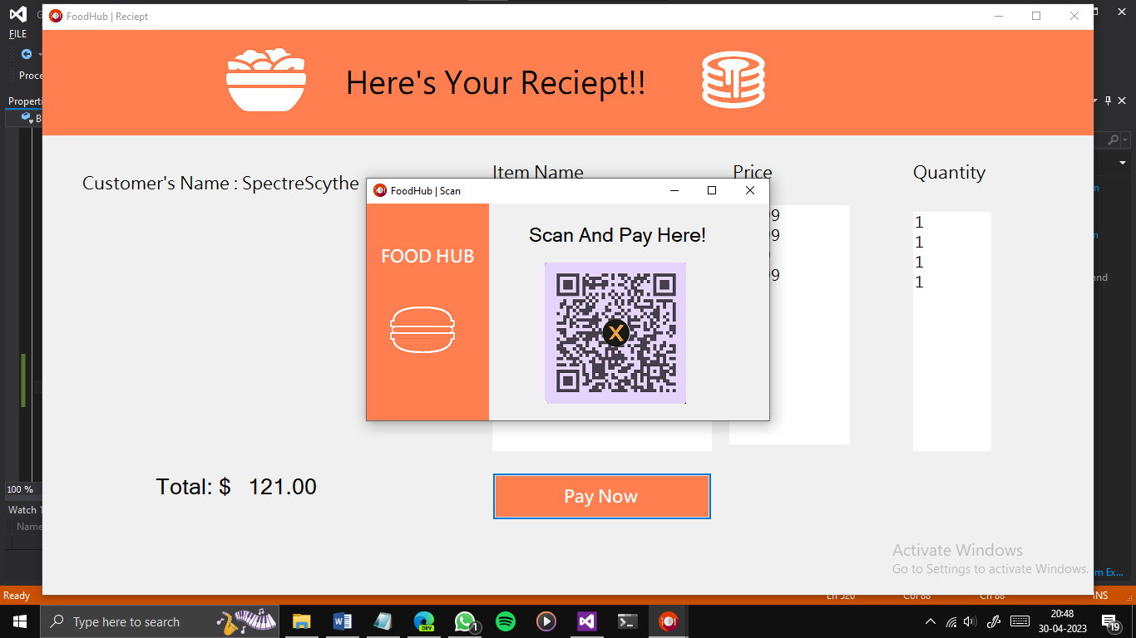

1. **Skills developed/ Learning outcomes**

The following skills are developed:

1. **Identifying:** Identifying the problem and cause of problem in the area related and prepare project proposals before starting the project.
2. **Derive:** Derive different possible solutions creatively.
3. **Data Collection:** Collect relevant data from different sources (books/the internet/the market/suppliers/experts and others through surveys/interviews).
4. **Designing:** Designing of micro project with minimum required resources (low cost).
5. **Developing:** Develop the prototype/model/ of the desired equipment/instrument/machine part etc.
6. **Teamwork:** Learn to work in a team and boost individual confidence.
7. **Time Management:** Timely completion of micro project as scheduled.
8. **Data Analysis:** Interpretation of data, drawing and analysis of laboratory calculations etc.
9. **Problem-solving:** Develop good problem-solving skills.
10. **Technical Writing:** Preparing a report of the proposed plan and final report.
11. **Presentation and communication skills:** Giving working model presentation of the micro project.
12. **Confidence:** Confidently, answer the questions asked about the project.

**Acknowledgement:** Acknowledge the help rendered by others in the success of the project.

1. **Applications of this microproject**

An online food ordering system or an online ordering platform is a place where customers can directly order from the restaurant instead of going through a third-party food delivery business. It is a web-based ordering system where customers using a mobile app can use the online user interface to order online. Online food ordering gives customers the freedom and choice to place an order at virtually any time, from anywhere, saving the time and resources typically spent on travelling to pick up a meal. It also gives the customers the advantage of reordering the favorite order in the easiest and hassle-free manner. Ordering online or through an app frees up staff while increasing order accuracy. It also trims the queue of customers waiting to order and even offers restaurants a means to track their guests' orders and habits.

**Micro Project Evaluation Sheet**

Name:Adnan Shaikh Enrollment no: 2100020129

Name of programme: Computer Engg Semester: 4th

Course title: GAD using VB.NET Code: 22034

Title of microproject: ONLINE FOOD DELIVERY APP

Course outcomes achieved:

1. Ordering online is convenient
2. No more waiting in long queues to place an order
3. Increased transparency in pricing
4. Multiple ways to pay for the order

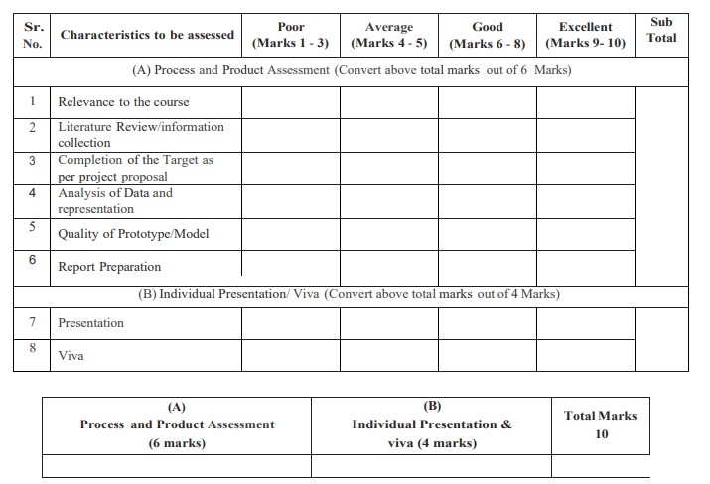

**Comments/Suggestions about teamwork/leadership/interpersonal communication ___________________________________________________________________________ ___________________________________________________________________________**

Name and designation of teacher: _____________________________________________ Dated signature: ______________________

**Micro Project Evaluation Sheet**

Name:Abdurrahman Qureshi Enrollment no: 2100020112

Name of programme: Computer Engg Semester: 4th

Course title: GAD using VB.NET Code: 22034

Title of microproject: ONLINE FOOD DELIVERY APP

Course outcomes achieved:

1. Ordering online is convenient
2. No more waiting in long queues to place an order
3. Increased transparency in pricing
4. Multiple ways to pay for the order



**Comments/Suggestions about teamwork/leadership/interpersonal communication ___________________________________________________________________________ ___________________________________________________________________________**

#### Name and designation of teacher: _____________________________________________ Dated signature: ______________________

**Micro Project Evaluation Sheet**

Name:Ansari Saad Enrollment no: 2100020102

Name of programme: Computer Engg Semester: 4th

Course title: GAD using VB.NET Code: 22034

Title of microproject: ONLINE FOOD DELIVERY APP

Course outcomes achieved:

1. Ordering online is convenient
2. No more waiting in long queues to place an order
3. Increased transparency in pricing
4. Multiple ways to pay for the order



**Comments/Suggestions about teamwork/leadership/interpersonal communication ___________________________________________________________________________ ___________________________________________________________________________**

#### Name and designation of teacher: _____________________________________________ Dated signature: ______________________

**Micro Project Evaluation Sheet**

Name:Arya More Enrollment no: 2100020097

Name of programme: Computer Engg Semester: 4th

Course title: GAD using VB.NET Code: 22034

Title of microproject: ONLINE FOOD DELIVERY APP

Course outcomes achieved:

1. Ordering online is convenient
2. No more waiting in long queues to place an order
3. Increased transparency in pricing
4. Multiple ways to pay for the order



**Comments/Suggestions about teamwork/leadership/interpersonal communication ___________________________________________________________________________ ___________________________________________________________________________**

#### Name and designation of teacher: _____________________________________________ Dated signature: ______________________

**Micro Project Evaluation Sheet**

Name:Adnan Kazi Enrollment no: 2100020117

Name of programme: Computer Engg Semester: 4th

Course title: GAD using VB.NET Code: 22034

Title of microproject: ONLINE FOOD DELIVERY APP

Course outcomes achieved:

1. Ordering online is convenient
2. No more waiting in long queues to place an order
3. Increased transparency in pricing
4. Multiple ways to pay for the order



**Comments/Suggestions about teamwork/leadership/interpersonal communication ___________________________________________________________________________ ___________________________________________________________________________**

#### Name and designation of teacher: _____________________________________________ Dated signature: ______________________